EXPERIMENT- 12
Q] Write a python program for Tic Tac Toe Game.
Aim-
To implement the Tic Tac Toe Game in Python for two players using a 3 × 3 board.
Algorithm-
- Create a 3 × 3 game board.
- Assign Player 1 as X and Player 2 as O.
- Display the empty board.
- Allow each player to enter the row and column position.
- Check whether the selected position is empty.
- Place the player's symbol (X or O) on the board.
- Check for a winning condition (row, column, or diagonal).
- If a player wins, display the winner and stop.
- If all cells are filled without a winner, declare the match as a draw.
- Stop.
Program-
board = [[' ' for _ in range(3)] for _ in range(3)]
def print_board():
print()
for row in board:
print(" | ".join(row))
print("-" * 9)
def check_winner(player):
for row in board:
if row == [player, player, player]:
return True
for col in range(3):
if all(board[row][col] == player for row in range(3)):
return True
if all(board[i][i] == player for i in range(3)):
return True
if all(board[i][2-i] == player for i in range(3)):
return True
return False
player = 'X'
for turn in range(9):
print_board()
print("Player", player)
row = int(input("Enter Row (0-2): "))
col = int(input("Enter Column (0-2): "))
if board[row][col] != ' ':
print("Cell already occupied!")
continue
board[row][col] = player
if check_winner(player):
print_board()
print("Player", player, "Wins!")
break
if player == 'X':
player = 'O'
else:
player = 'X'
else:
print_board()
print("Match Draw!")

Sample Input-
Player X
Row = 0
Column = 0
Player O
Row = 1
Column = 1
Player X
Row = 0
Column = 1
Player O
Row = 2
Column = 2
Player X
Row = 0
Column = 2

Sample Output:
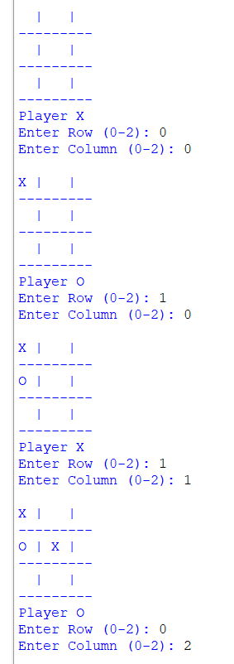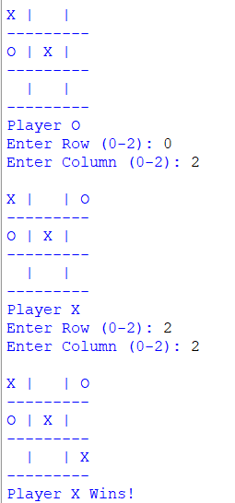

Result-
The Tic Tac Toe Game was implemented successfully in Python. The program allows two players to play alternately, checks for valid moves, detects the winner, and declares a draw if no player wins.

